ipconfig

* Purpose: Displays network configuration details for all network interfaces. Provides IP addresses, subnet masks, and default gateways. It’s useful for troubleshooting network settings.
* Usage:
  + ipconfig (shows basic network configuration)
  + ipconfig /all (shows detailed information including DNS servers and MAC addresses)
  + ipconfig /release (releases the current IP address)
  + ipconfig /renew (renews the IP address)

ping

* Purpose: Tests network connectivity to a specific IP address or domain name. Sends ICMP Echo Requests and measures the round-trip time to check if a host is reachable.
* Usage:
  + ping [hostname or IP] (e.g., ping google.com or ping 192.168.1.1)
  + ping -t [hostname or IP] (continuously pings until stopped)
  + ping -n [count] [hostname or IP] (sends a specified number of pings, e.g., ping -n 4 google.com)

netstat

* Purpose: Displays active network connections, listening ports, and network statistics. Useful for monitoring network activity and diagnosing issues.
* Usage:
  + netstat (shows active connections and listening ports)
  + netstat -an (shows all connections and listening ports with numerical addresses)
  + netstat -r (shows the routing table)
  + netstat -s (shows network statistics by protocol)

tracert

* Purpose: Traces the route that packets take from your computer to a specified destination. Shows each hop along the way and helps diagnose routing issues and network delays.
* Usage:
  + tracert [hostname or IP] (e.g., tracert google.com or tracert 8.8.8.8)
  + tracert -d [hostname or IP] (disables hostname resolution to speed up the trace)

nslookup

* Purpose: Queries DNS servers to obtain domain name or IP address mappings. Useful for diagnosing DNS issues and verifying DNS configurations.
* Usage:
  + nslookup [hostname or IP] (e.g., nslookup google.com or nslookup 8.8.8.8)
  + nslookup (starts interactive mode for further queries)
  + nslookup [hostname] [DNS server] (queries a specific DNS server)

hostname

* Purpose: Displays the name of the computer as recognized on the network. Useful for identifying the system’s network name.
* Usage:
  + hostname (shows the current hostname of the computer)

systeminfo

* Purpose: Provides detailed information about the computer’s configuration including OS version, build, hardware details, and system uptime.
* Usage:
  + systeminfo (displays comprehensive system information)

getmac

* Purpose: Displays the MAC addresses of network interfaces. Useful for identifying the hardware addresses of network adapters.
* Usage:
  + getmac (lists MAC addresses of network interfaces)
  + getmac /v (shows detailed information including the transport name)

route

* Purpose: Displays or modifies the IP routing table. Useful for managing routing entries and diagnosing routing issues.
* Usage:
  + route print (shows the routing table)
  + route add [destination] mask [mask] [gateway] (adds a new route)
  + route delete [destination] (removes a route)

arp

* Purpose: Displays or modifies the ARP cache, which maps IP addresses to MAC addresses. Useful for managing address resolution and troubleshooting network issues.
* Usage:
  + arp -a (shows the ARP table)
  + arp -d [IP address] (deletes an ARP entry)
  + arp -s [IP address] [MAC address] (adds a static ARP entry)

### ethtool

Purpose: Displays or modifies network interface parameters. Useful for managing and troubleshooting network interfaces on Linux systems.

Usage:

* ethtool [interface]: Displays information about the specified network interface (e.g., eth0).
* ethtool -s [interface] [options]: Sets specific parameters for the network interface. Options include settings like speed, duplex mode, and autonegotiation (e.g., ethtool -s eth0 speed 1000 duplex full).
* ethtool -i [interface]: Displays driver information for the specified interface.
* ethtool -p [interface]: Causes the LED on the network interface to blink, helping to physically locate the device.

### dig

Purpose: Queries Domain Name System (DNS) servers to retrieve domain name or IP address information. Useful for diagnosing DNS issues and looking up DNS records.

Usage:

* dig [domain]: Performs a DNS lookup for the specified domain (e.g., dig example.com). This will return the domain's A record by default.
* dig [domain] [record type]: Queries for a specific type of DNS record (e.g., dig example.com MX for mail exchange records).
* dig @server [domain]: Queries a specific DNS server (e.g., dig @8.8.8.8 example.com to query Google's DNS server).
* dig -x [IP address]: Performs a reverse DNS lookup to find the domain associated with an IP address.

192.168.2.0– network id

192.168.2.255 –broadcast id

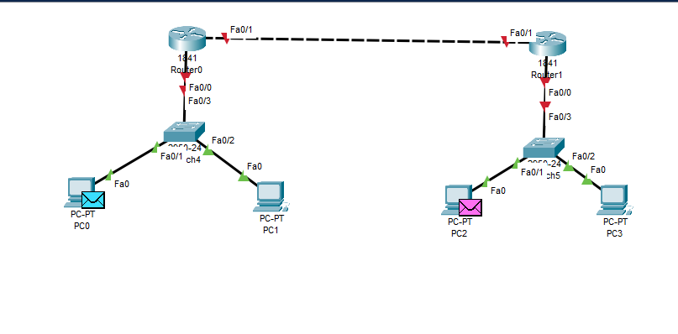  
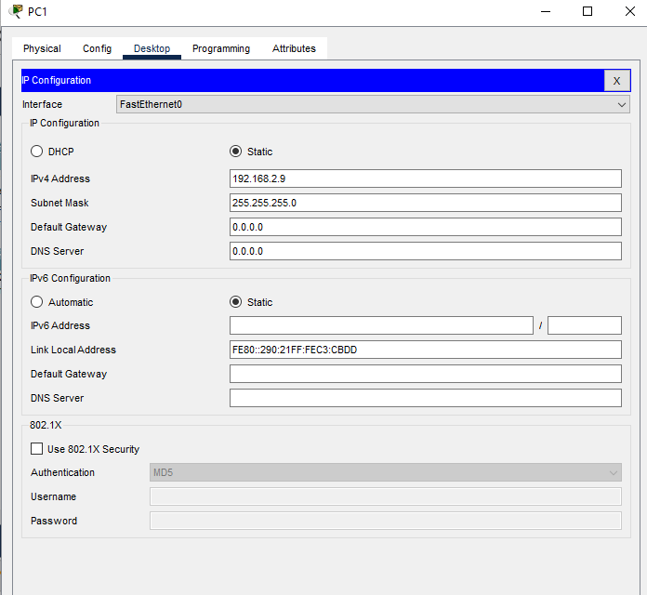  
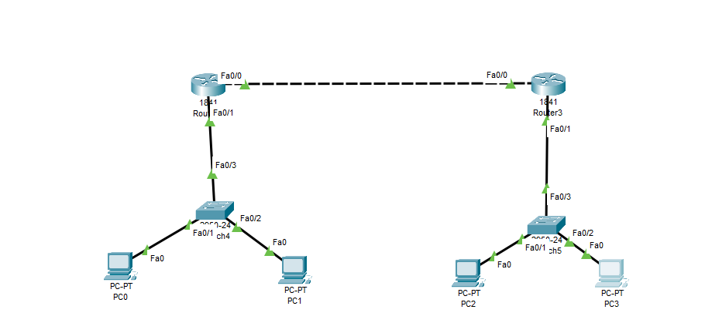  
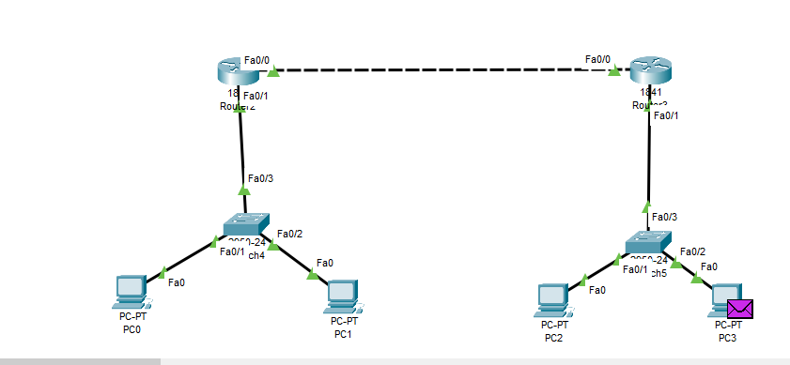  
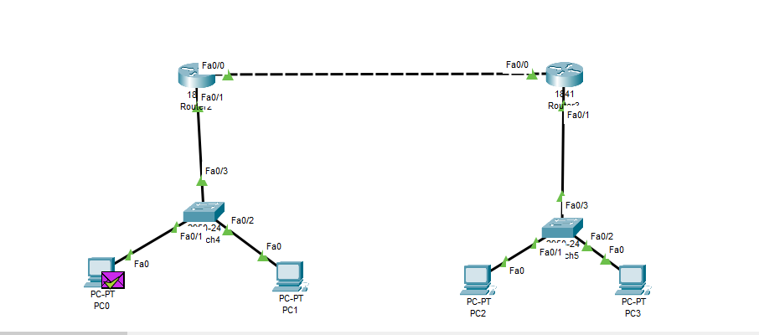

16/9/24 - ……………………………………………………………………………………………………………

